Terraform Task-04
2). Execute the script shown in the video.
Terraform versions:
Terraform downloaded the latest version for both local and random when tried to execute the command terraform init
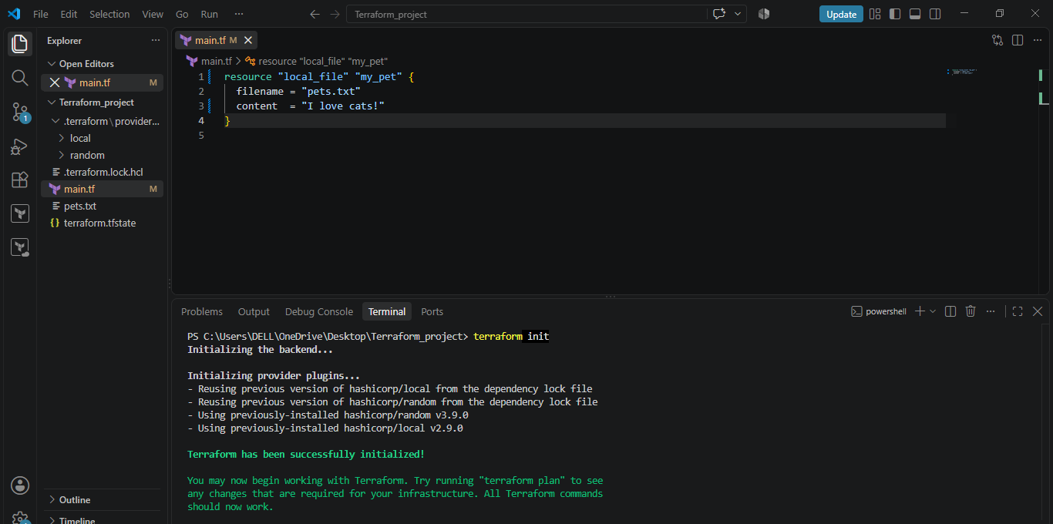
Latest version of local in terraform registry is v2.9.0
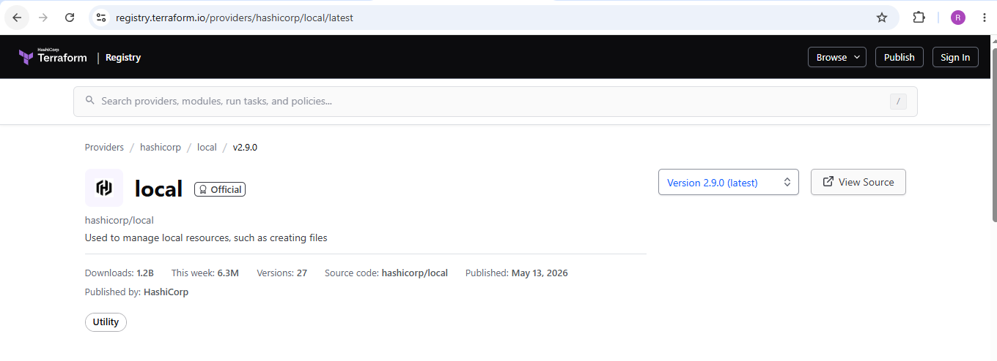

To use specific provider:
We want terraform to download 2.3.0 version.
Use terraform block in main.tf file, it will download the specific version that we want to download.
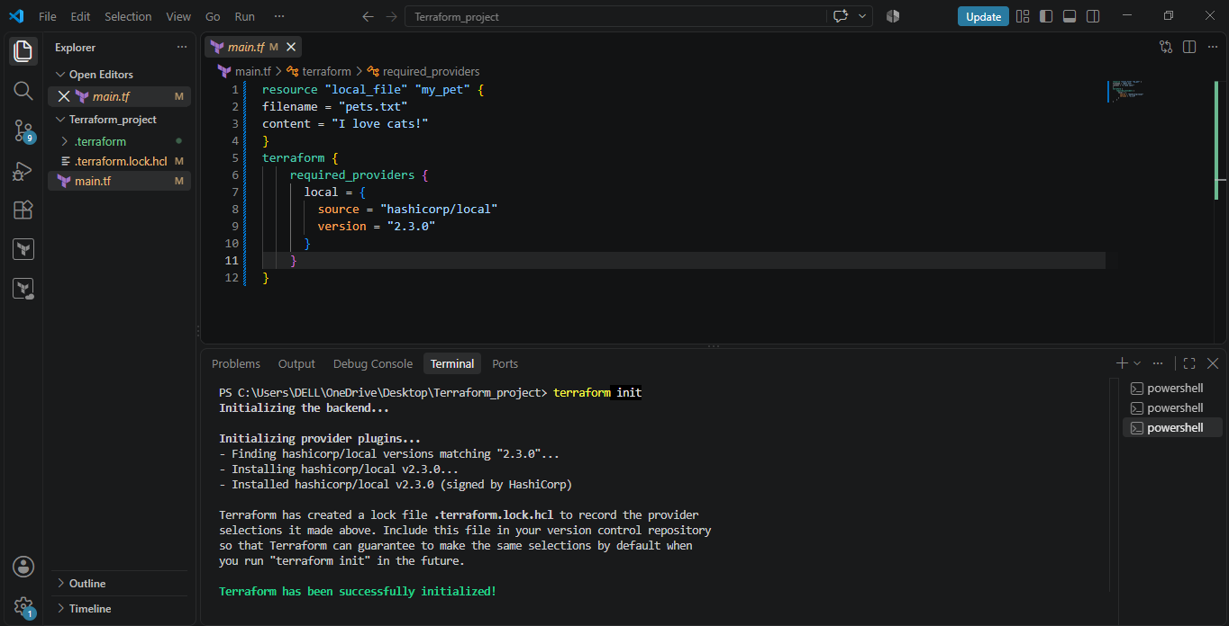
Version !=2.3.0
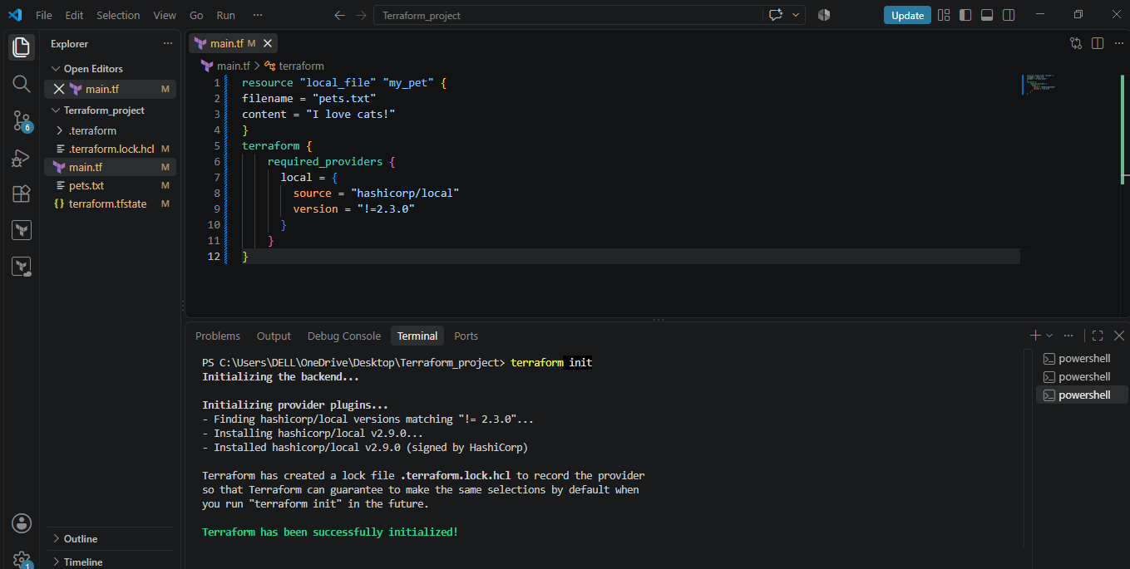

As we say not to download 2.3.0 by passing !=2.3.0, it downloads any other version other than 2.3.0, so it downloaded 2.9.0
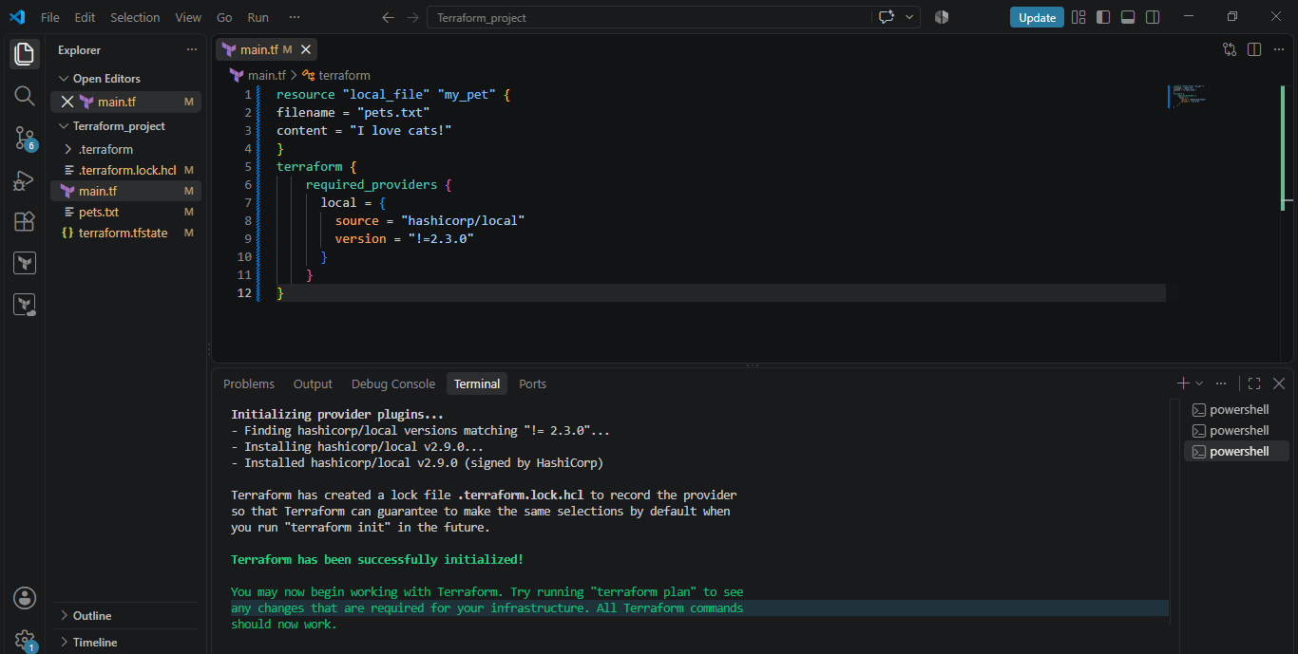
Version = <2.3.0
As given the required provider to be <2.3.0 it downloaded 2.2.3 version
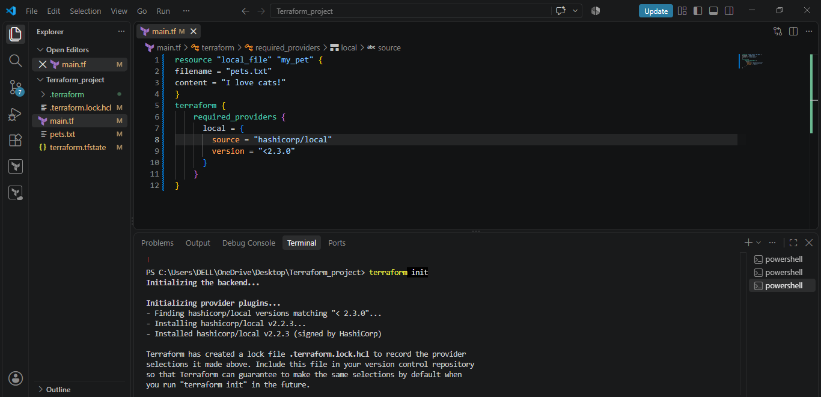
Version >2.3.0
As we used required provider to be >2.3.0, it downloaded 2.9.0 version i.e the latest which is already greater than 2.3.0
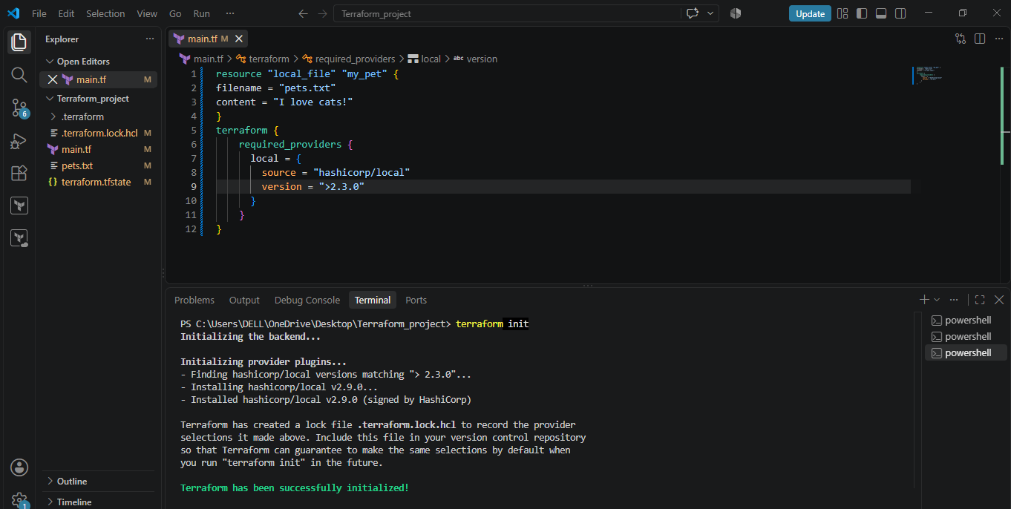
Data source:
Created a file named dogs.txt and placed content in that file.
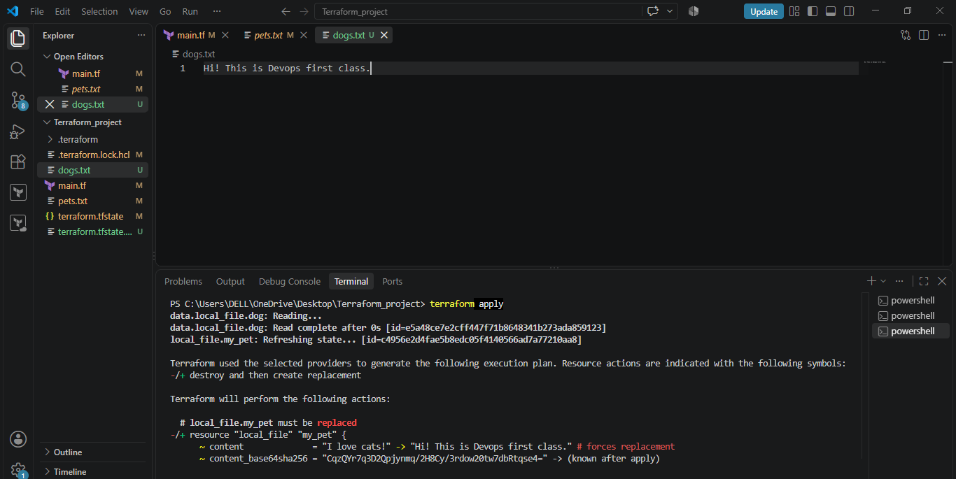

In order to replicate the content present in dogs.txt file to pets.txt file, we use
Content= data.local_file.dog.content
It replaced the content in pets.txt file with the content in dogs.txt file and ouput is as shown below:
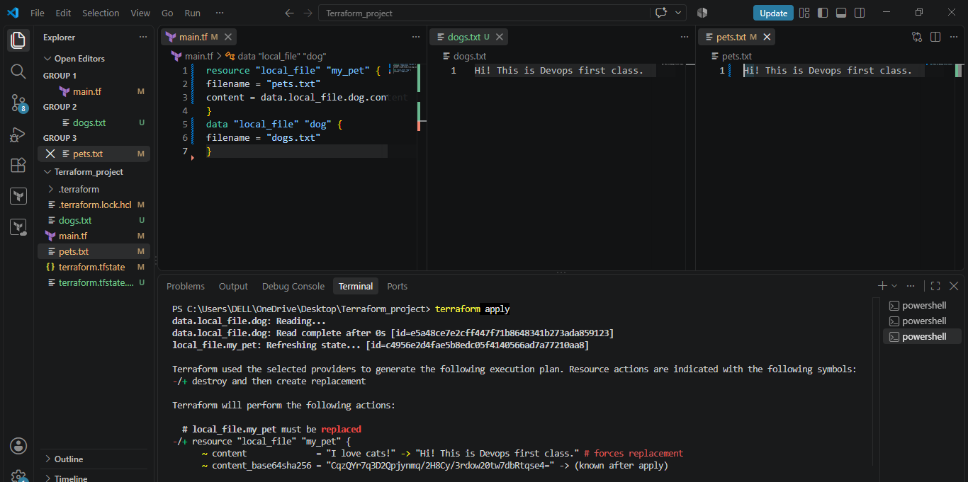
Meta arguments:
1. Count
Using count =3 and by declaring 3 file names in variable.tf file.
Terraform creates 3 files but these files are not displayed in the left side panel.
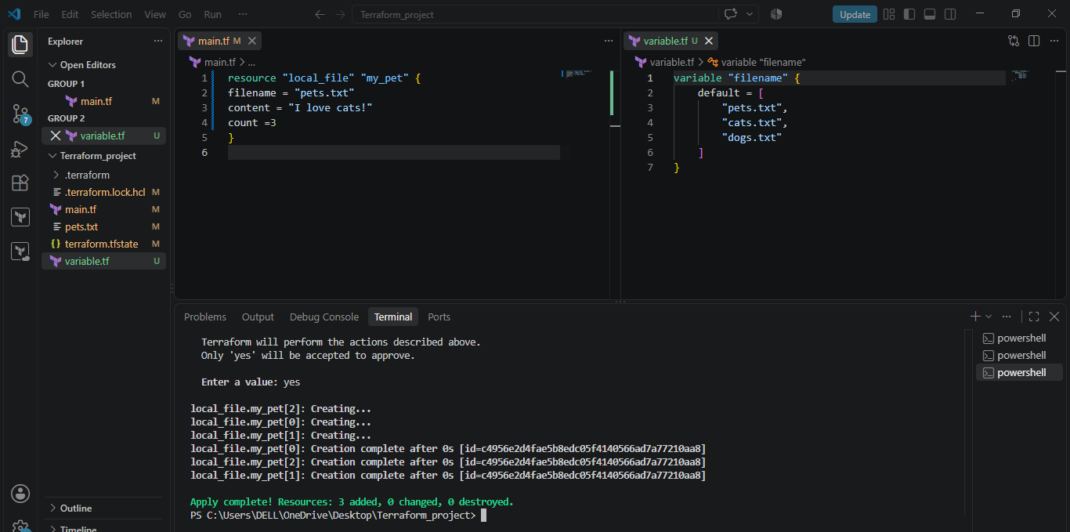
To display the files in left panel used the attribute count as
count= length (var.filename)
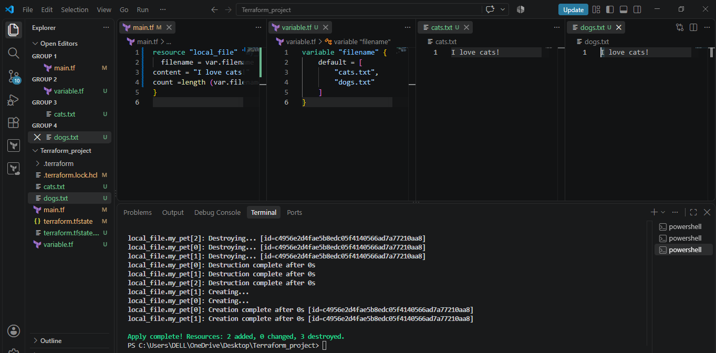

2. For each:
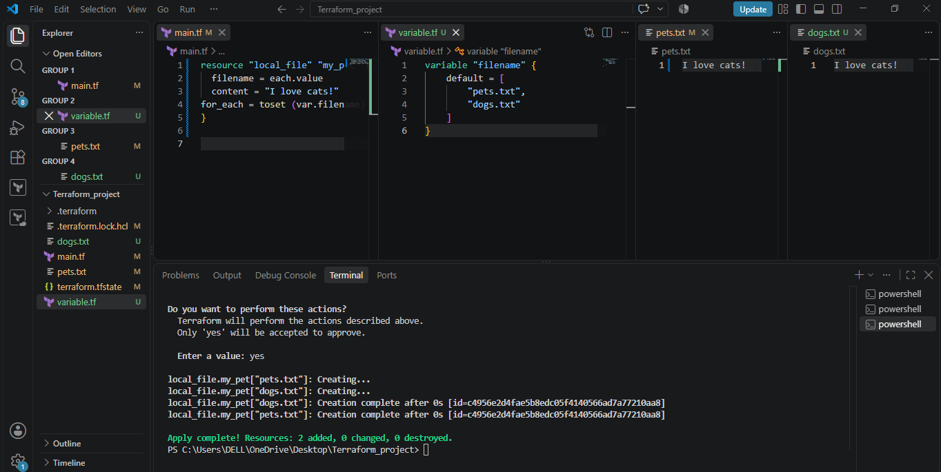

Create AWS resources using Terraform:
1. Script to create AWS IAM user:
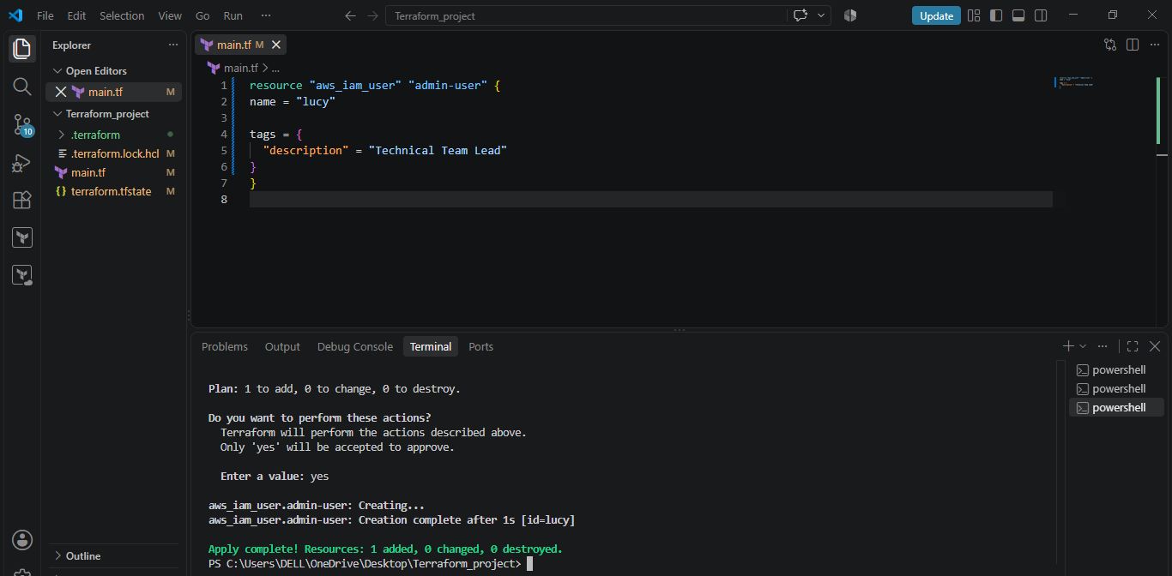

Verified the Iam user on AWS:
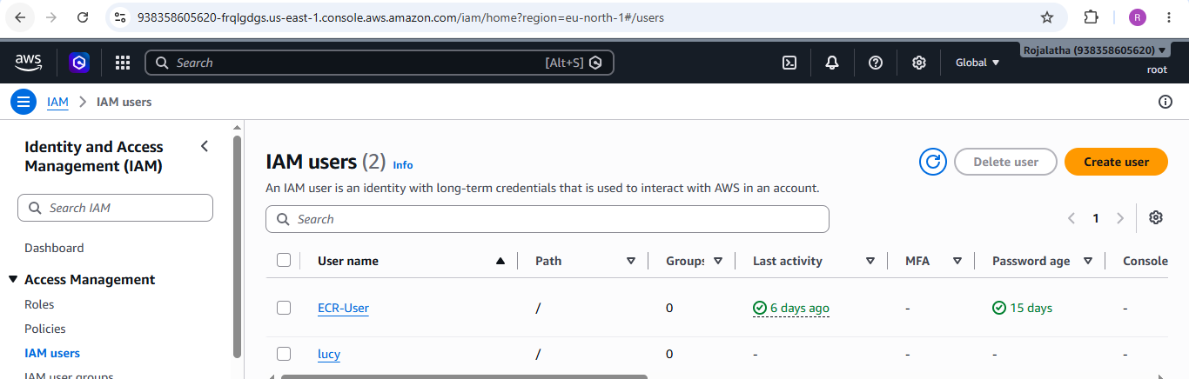

2. Create IAM user with policy attached to the user:
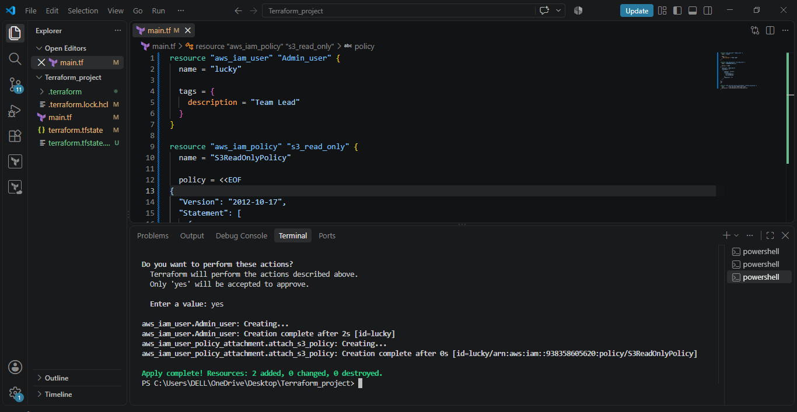

Verified the user with policy attached:
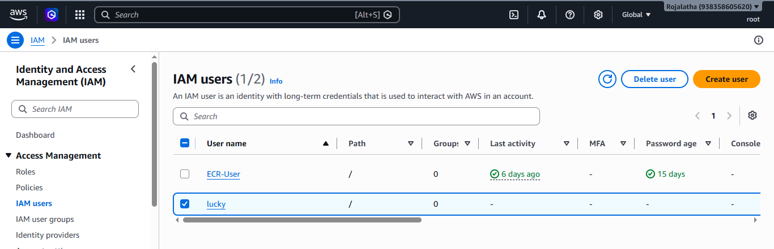
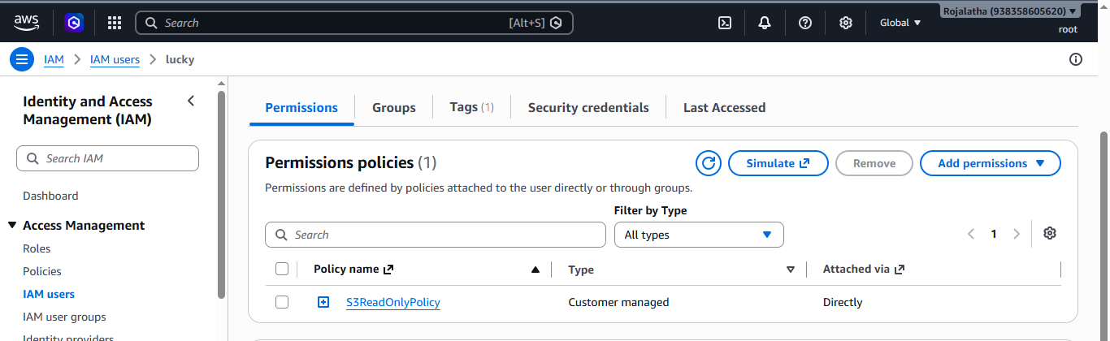

3). Integrate Terraform in Jenkins using the Terraform plugin.
Install Terraform on the Jenkins server/agent
Make sure the terraform command is available.
Step 1:Verify: terraform version
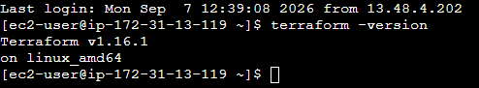

Step 2: Open Jenkins GUI using http://<EC2-PUBLIC-IP>:8080
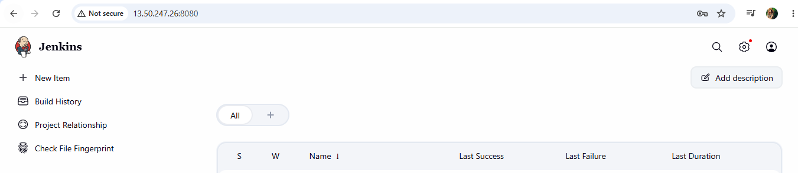

Step 3: Install the Terraform plugin
- Go to Jenkins → Manage Jenkins → Plugins.
- Search for the Terraform plugin and install it.
- Restart Jenkins if required.
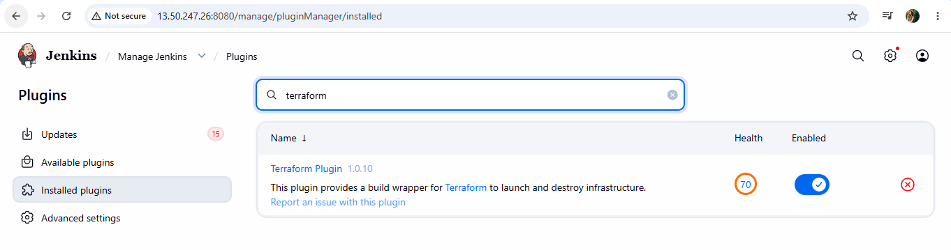

Step 4: Configure Terraform
- Go to Manage Jenkins → Tools.
- Add/configure the Terraform installation.
- Give it a name such as terraform.
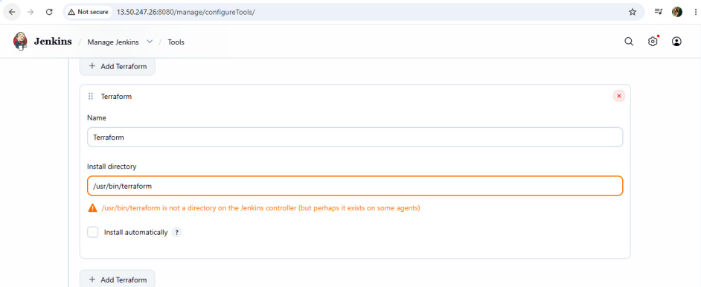

Step 5: Create a Jenkins Pipeline
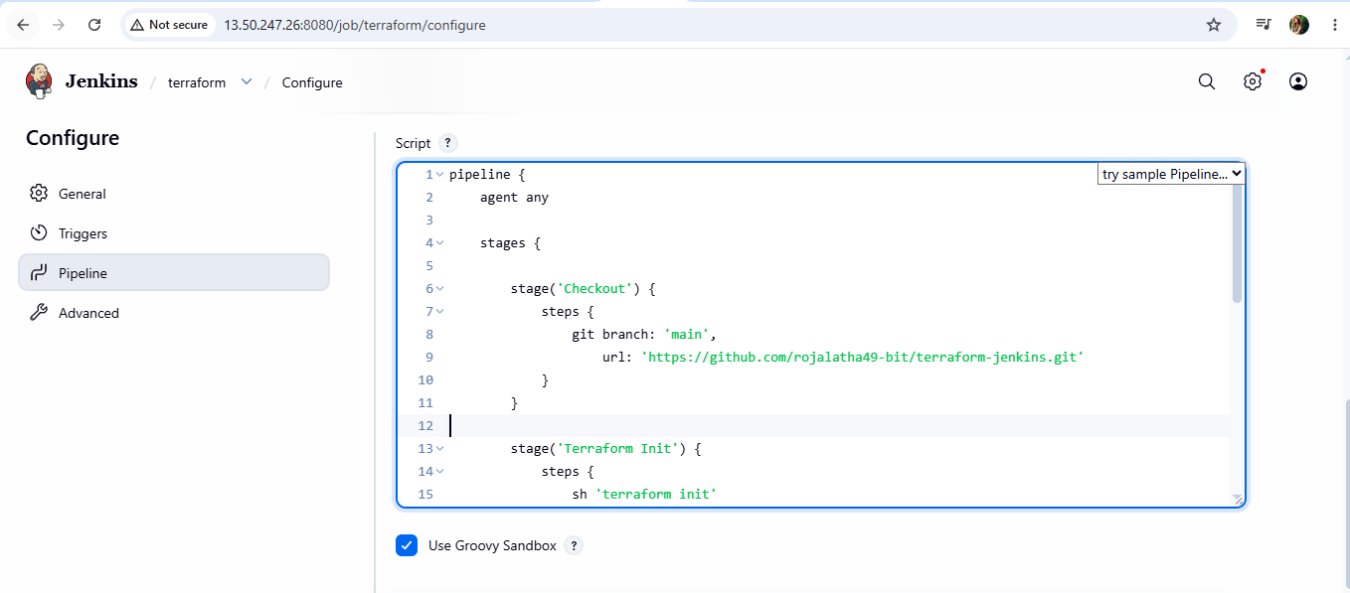

Step 6: Execute the job by clicking ob build now:
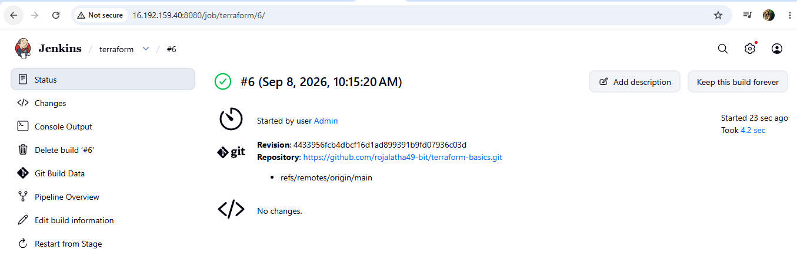

4). Create a CI/CD pipeline for a Nodejs Application: https://github.com/betawins/Trading-UI.git
Step 1: Update packages
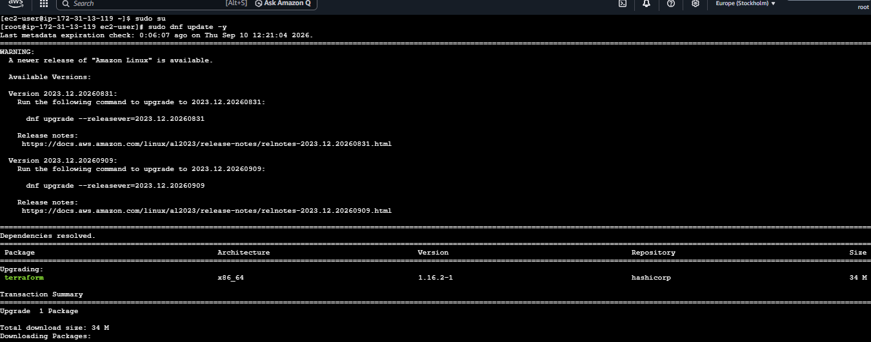
Install Node.js 2.0:
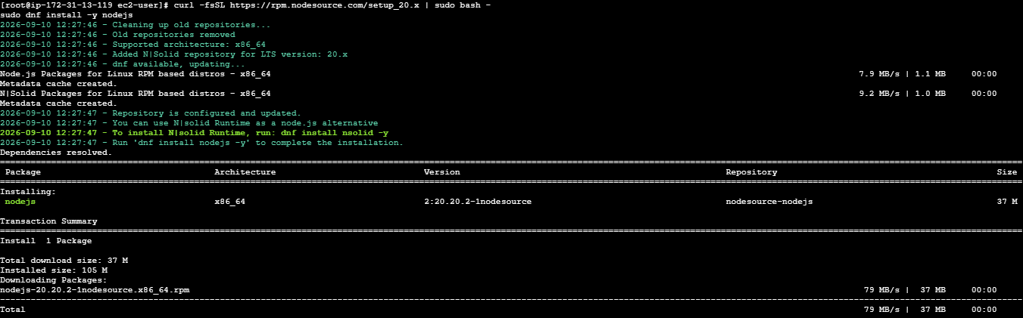

Check the versions of Nodejs and npm:
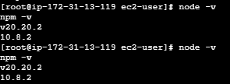

Install pm2 and verify the version:
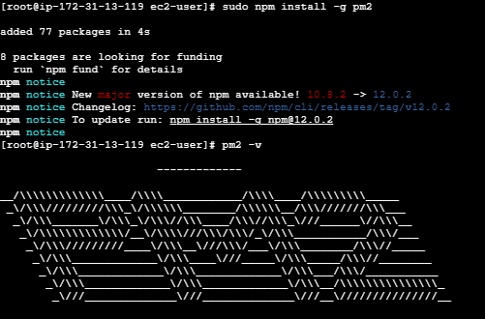

Step 2: Open Jenkins console:
Create a new job:
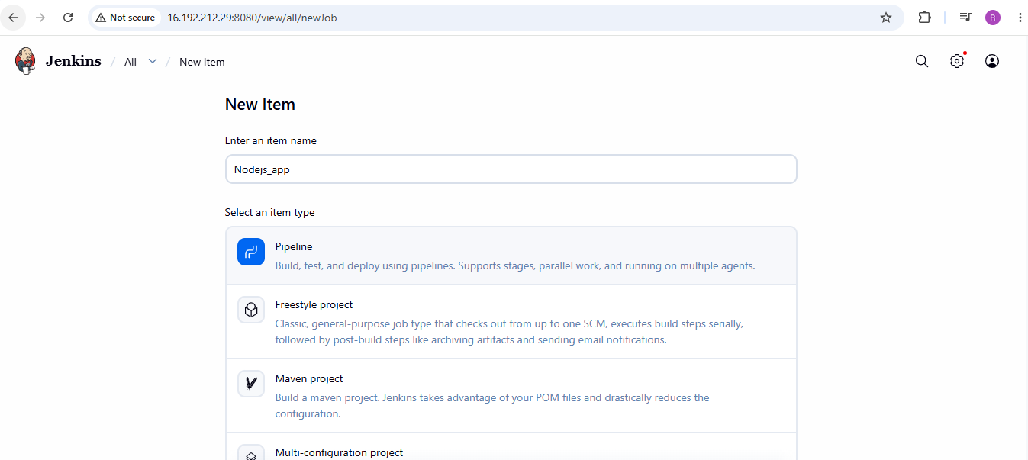

Configure pipeline script from SCM:
In SCM select Git and paste the url:
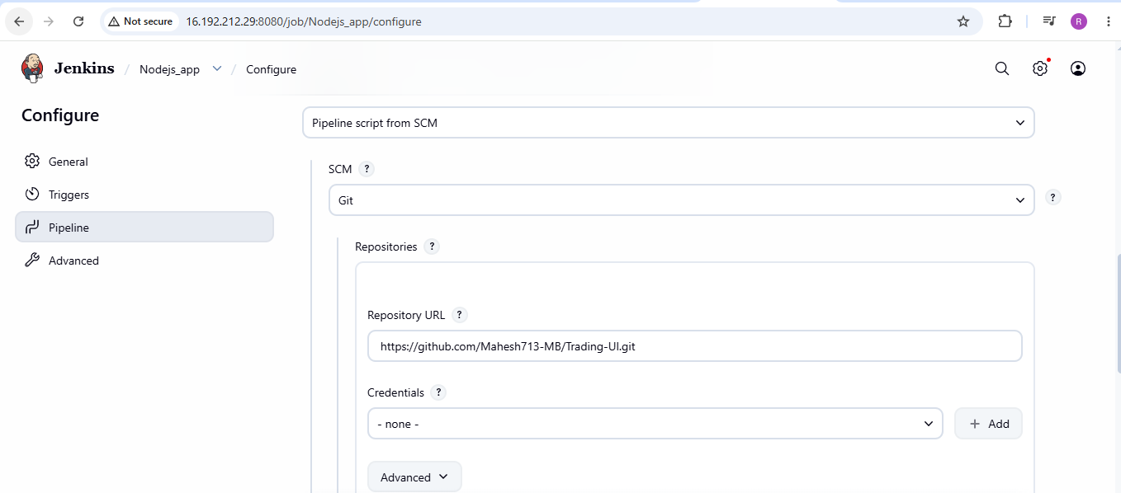

Now execute the job by clicking on Build now:
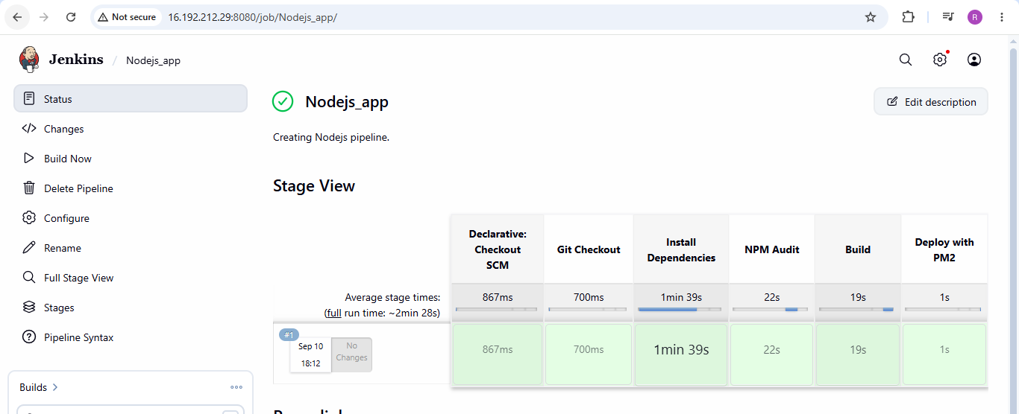

Deploy the application
Check git version and clone the repository:
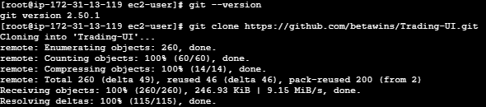

Start your Node.js application with PM2
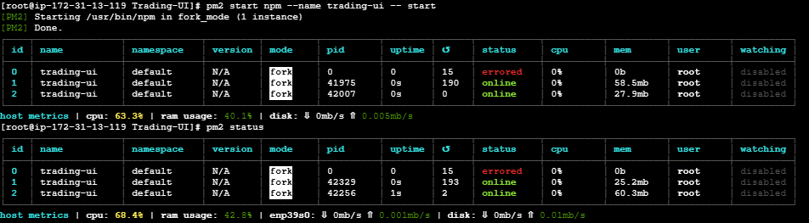

ls -l build gives list the contents/details of the build directory.
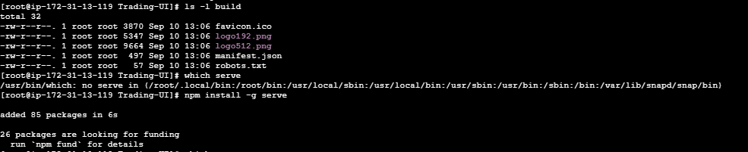

Checked serve version:
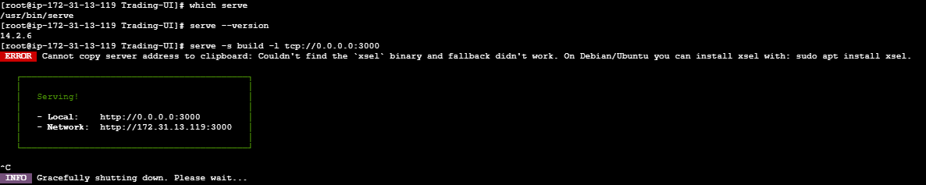

Serve React/Node frontend build folder as a web server and keep it running with PM2.
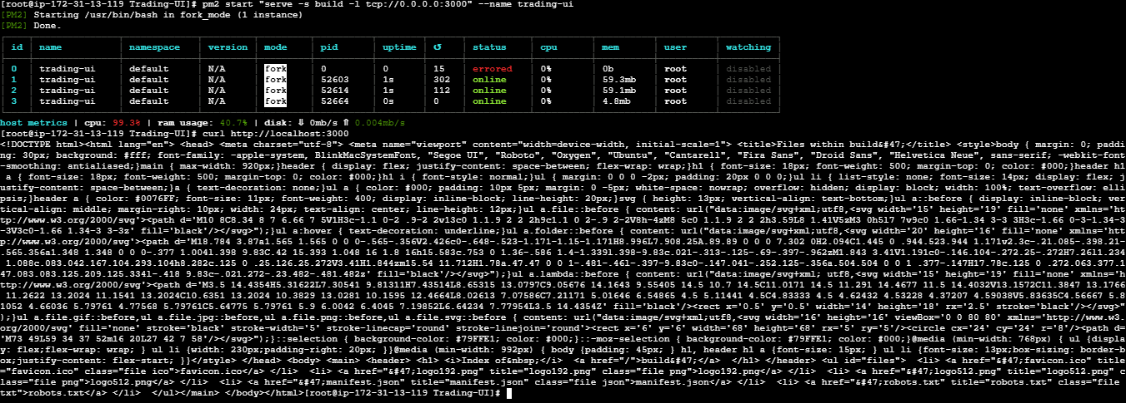

Now using <Public ip>:3000 access the application in browser:

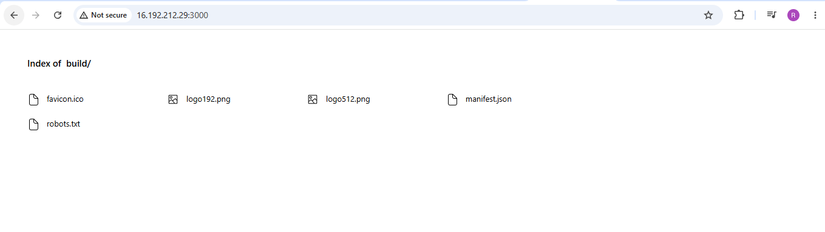

5). Explain 10 Maven commands.
10 important Maven commands, explained in simple terms. These are commonly used in Java projects and Jenkins CI/CD pipelines.
# | Maven command | Purpose
1 | mvn -version | Check Maven version
2 | mvn validate | Check whether the project is valid
3 | mvn compile | Compile the Java source code
4 | mvn test | Run unit tests
5 | mvn package | Create JAR/WAR package
6 | mvn install | Build and store artifact in local repository
7 | mvn clean | Delete previous build files
8 | mvn clean install | Clean, build, test, and install
9 | mvn dependency:tree | Display project dependencies
10 | mvn deploy | Upload artifact to a remote repository

